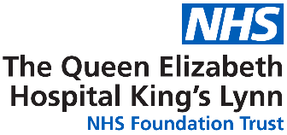
Workforce Race Equality Standard (WRES) and Workforce Disability Equality Standard (WDES)

2022 - 2023

NHS Workforce Race Equality Standard

Implementing the Workforce Race Equality Standard (WRES) is a requirement for NHS commissioners and NHS healthcare providers including independent organisations, through the NHS standard contract.

The NHS Equality and Diversity Council announced on 31 July 2014 that it had agreed action to ensure employees from black and minority ethnic (BME) backgrounds have equal access to career opportunities and receive fair treatment in the workplace.

This is important because studies shows that a motivated, included and valued workforce helps deliver high quality patient care, increased patient satisfaction and better patient safety.
In April 2015, after engaging and consulting with key stakeholders including other NHS organisations across England, the WRES was mandated through the NHS standard contract, starting in 2015/16. From 2017, independent healthcare providers are required to publish their WRES data.

NHS providers are expected to show progress against a number of indicators of workforce equality, including a specific indicator to address the low numbers of BME board members across the organisation.
Results
The 2022/23 WRES data has nine indicators covering the areas outlined below:
WRES Indicator 1 - compare the data for white and BME staff: Percentage of staff in each of the AfC Bands 1-9 and VSM (including executive Board members) compared with the percentage of staff in the overall workforce.

- Indicator 1 shows the Trust with a 2.5% increase in Black, Asian minority, and ethnic representation at 27.5%, further detail can be seen in appendix 1-4 for more details of the breakdown.

WRES Indicator 2 - compare the data for white and BME staff: Relative likelihood of staff being appointed from shortlisting across all posts. This indicator will be based on financial year end data.
2017 | 2018 | 2019 | 2020 | 2021 | 2022 | 2023 | Trend
5.07 | 1.25 | 1.46 | 1.34 | 0.84 | 1.20 | 1.29 | 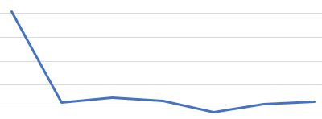
(A figure below “1” would indicate that white candidates are less likely than BME candidates to be appointed from shortlisting). Therefore, a figure close to 1 is ideal.

- The trust has implemented a diverse recruitment panel process which includes representatives of diverse genders, a representative from People Services and a REACH member for bands 7 and above and all medical appointments. This has increased the overall number of diverse candidates being appointed.
- The Trust has been working collectively with our ESR team and recruitment in capturing our ethnicity data. Between 2021 and 2022/3 the Trust has significantly reduced the ‘not stated’ ethnicity response from over 20% of applicants to under 1%. This has improved the quality of the data and may account for the 1.2 to 1.29 decline.

WRES Indicator 3 - compare the data for white and BME staff: Relative likelihood of staff entering the formal disciplinary process, as measured by entry into a formal disciplinary investigation.
2017 | 2018 | 2019 | 2020 | 2021 | 2022 | 2023 | Trend
0.71 | 1.84 | 0.63 | 0.29 | 0.86 | 1.32 | 0.41 | 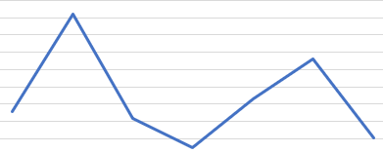
*(A figure below “1” would indicate that BME staff members are less likely than white staff to enter the formal disciplinary process.)

- The data showing a positive improvement for BME staff members. However, there were fewer than 40 qualifying processes in 2022/23 so a change of 1 individual entering a formal process can significantly change the ratio.

WRES Indicator 4 – compare the data for white and BME staff: Relative likelihood of staff accessing non-mandatory training and CPD.
2017 | 2018 | 2019 | 2020 | 2021 | 2022 | 2023 | Trend
1.03 | 1.05 | 0.98 | 1.00 | 0.95 | 0.96 | 0.99 | 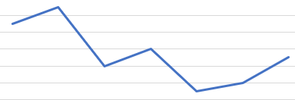
*(A figure below “1” would indicate that white staff members are less likely to access non-mandatory training and CPD than BME staff)

- Indicator 4 show there has been a decline from the previous year, however, the ideal score for this measure is 1.

Indicators 5-8 from 2022 staff survey data.

WRES Indicator 5 - compare the outcomes of the responses for white and BME staff: Percentage of staff experiencing harassment, bullying or abuse from patients, relatives or the public in last 12 months.
 | 2017 | 2018 | 2019 | 2020 | 2021 | 2022 | National | Trend
BME | 40.4% | 37.4% | 28.8% | 23.4% | 36.8% | 43.4% | 29.2% | 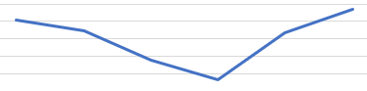
WHITE | 31.2% | 30.4% | 34% | 36.9% | 25.0% | 25.8% | 27.0% | 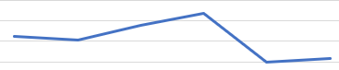
Appendix 11, 12 & 13 is data directly from the 2022 National Staff Survey, which is indicator 5 in WRES. The data suggests that African, nurses and midwives of those within the age range of 21-30 are those who are most likely to have experienced harassment, bullying or abuse from patients/service users, their relatives or members of the public.

- The data from indicator 5 shows a significant decline for staff experiencing harassment, bullying or abuse from patients and the public. Since this data was collected the data, we have launched a 12 week ‘No Excuse for Abuse’ campaign that our staff spearheaded. This campaign is supported by a newly updated policy, managing unacceptable behaviours and increased engagement with the system, unions and our estates and facilities teams.

WRES indicator 6 - compare the outcomes of the responses for white and BME staff: Percentage of staff experiencing harassment, bullying or abuse from staff in last 12 months.
 | 2017 | 2018 | 2019 | 2020 | 2021 | 2022 | National | Trend
BME | 27.2% | 29.1% | 37.2% | 29.1% | 34.1% | 33.7% | 27.6% | 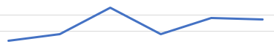
WHITE | 28.4% | 31.1% | 29.4% | 27.7% | 29.9% | 27.3% | 22.5% | 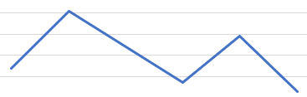

- A positive improvement from the previous year regarding staff experience harassment, bullying or abuse. However, above the national average, our ‘No Excuse for Abuse’ campaign will support this metric to improve.
- We are also working with unions and managers to ensure that policies and processes are equitably applied and conducted in a timely manner.

WRES Indicator 7 - compare the outcomes of the responses for white and BME staff: Percentage of staff believing that their organisation provides equal opportunities for career progression or promotion.
 | 2017 | 2018 | 2019 | 2020 | 2021 | 2022 | National | Trend
BME | 55.3% | 43.2% | 46.5% | 45.6% | 39.2% | 47.9% | 44.4% | 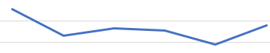
WHITE | 62.7% | 52.0% | 55.4% | 56.0% | 58.5% | 57.3% | 58.7% | 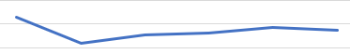
*Positive improvement for BME staff in 2022

- Indicator 7 shows a significant improvement in terms of providing equal opportunities for career advancement or promotion, with a nearly nine percent improvement and higher than the national result. While this still lags behind the experience of white staff, the Trust has been promoting system and regional learning opportunities for BAME background staff.
- The Trust is considering career development opportunities and coaching for internationally recruited nurses who have worked for the Trust for a number of years to support their development.
- A bespoke REACH development programme, where two colleagues out of 5 have received a promotion and one colleague a sideways move. A similar programme is under development for our disabled staff group.

WRES Indicator 8 - compare the outcomes of the responses for white and BME staff: In the last 12 months have you personally experienced discrimination at work from any of the following?
(b) Manager/team leader or other colleagues
 | 2017 | 2018 | 2019 | 2020 | 2021 | 2022 | National | Trend
BME | 16.8% | 16.8% | 17.2% | 18.7% | 21.1% | 19.9% | 17.9% | 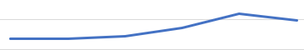
WHITE | 10.4% | 9.1% | 7.5% | 6.6% | 6.9% | 7.6% | 6.8% | 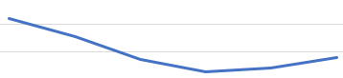
*Positive improvement for BME staff in 2022

- Indicator 8 shows a positive improvement from BME experience discrimination at work. However, the is still higher than the national average and significantly higher than the proportion of white staff.

WRES Indicator 9 - compare the difference for white and BME staff: Percentage difference between (i) the organisations’ Board voting membership and its overall workforce and (ii) the organisations’ Board executive membership and its overall workforce.
 | 2020 | 2021 | 2022 | 2023
White | 16 | 15 | 14 | 14
BME | 0 | 1 | 2 | 2
Unknown | 0 | 0 | 1 | 1

- 2023 remains the same as 2022, this will see a decline for 2024 which known leavers in this financial year. However, the planned recruitment of two associate non-executive directors will support the representation at board level and begin to build a diverse talent pipeline.

Action Plan
The WRES action plan (appendix 6) highlights the objective, supporting data, actions currently in place and future actions. It also provides a RAG rating for the actions relating to each metric. The majority of the 23/24 actions are currently amber.
Key action for 23/24 include:
- Recruitment of two Associate NED roles
- Recruitment of coaches across the Trust
- Introduction of Manager Fundamental Training
- Continued promotion of ‘No excuse for Abuse’ campaign
NHS Workforce Disability Equality Standard (WRES)
The Workforce Disability Equality Standard (WDES) is a set of ten specific measures (metrics) which enables NHS organisations to compare the workplace and career experiences of disabled and non-disabled staff. NHS organisations use the metrics data to develop and publish an action plan. Year on year comparison enables NHS organisations to demonstrate progress against the indicators of disability equality.
The WDES is important, because research shows that a motivated, included and valued workforce helps to deliver high quality patient care, increased patient satisfaction and improved patient safety.
The WDES enables NHS organisations to better understand the experiences of their disabled staff and supports positive change for all staff by creating a more inclusive environment for disabled people working and seeking employment in the NHS.
National healthcare organisations are not mandated by the WDES but may report metrics data and publish WDES annual reports in the spirit of transparency.

WRES Results for 2022/23

WDES Indicator 1 - Percentage of staff in Agenda for Change (AfC) pay-bands or medical and dental subgroups and very senior managers (including Executive Board members) compared with the percentage of staff in the overall workforce (Appendix 7).

- A positive improvement in unknown data, demonstrating how staff are confident in updating their personal data, showing a decrease of 5.5% compared to previous years. However, band 2 staff are particularly unlikely to share their disability status.

WDES Indicator 2 - Relative likelihood of non-disabled staff compared to Disabled staff being appointed from shortlisting across all posts.
2020 | 2021 | 2022 | 2023 | Trend
1.36 | 1.10 | 0.84 | 1.20 | 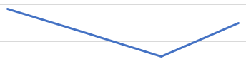
(A relative likelihood of 1 indicates that there is no difference: i.e. non-disabled applicants are equally as likely of being appointed from shortlisting as Disabled applicants.)

- A decline for disabled staff being appointed from shortlisting, our planned interview training for colleagues will support the development of recruiting with values.
- As the numbers involved are small a similar process to that which improved the data quality around ethnicity data recording for applicants is needed.

WDES Indicator 3 - Relative likelihood of Disabled staff compared to non-disabled staff entering the formal capability process on the grounds of performance, as measured by entry into the formal capability procedure.
2021 | 2022 | 2023 | Trend
1.11 | 1.05 | 1.35 | 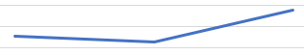
(A relative likelihood of 1 indicates that there is no difference, i.e. Disabled staff are equally as likely as nondisabled staff to enter formal capability processes.)

- A decline for disabled staff where disabled staff entering a capability process, our people services workplan includes the recruitment of mediators, investigation officers, a full review of our Trust policies will support the metric to improve.
- The number of cases are small but the increase from 2022 is a concern.

Indicators 4-9 from 2022 staff survey data.

WDES Indicator 4a – Percentage of Disabled staff compared to non-disabled staff experiencing harassment, bullying or abuse from:
Patients/Service users, their relatives or other members of the public, Managers and Other colleagues.
 |  | 2018 | 2019 | 2020 | 2021 | 2022
Manager | Disabled | 26.2% | 23.2% | 17.7% | 22.6% | 24.3%
 | Non-disabled | 15.1% | 12.2% | 13.2% | 12.9% | 11.0%
Other colleagues | Disabled | 32.6% | 37.4% | 27.9% | 33.0% | 32.4%
 | Non-disabled | 21.5% | 20.2% | 18.9% | 20.4% | 19.9%
Patients/public | Disabled | 38.1% | 35.6% | 26.5% | 33.8% | 31.6%
 | Non-disabled | 29.9% | 28.0% | 25.0% | 24.7% | 28.3%

- Increase for disabled staff in 2022 for manager, and decline for other colleagues, patients and public. Our ‘No Excuse for Abuse’ campaign will support the improvements, as highlighted in WRES indicator 5, having also been supported by our executive team.
- Manager training programmes will need to highlight the ability to have difficult conversations as well as the importance of supporting colleagues with reasonable adjustments.

WDES Indicator 4b - Percentage of Disabled staff compared to non-disabled staff saying that the last time they experienced harassment, bullying or abuse at work, they or a colleague reported it.
 | 2018 | 2019 | 2020 | 2021 | 2022 | Trend
Disabled | 43.1% | 43.2% | 49.7% | 51.5% | 48.0% | 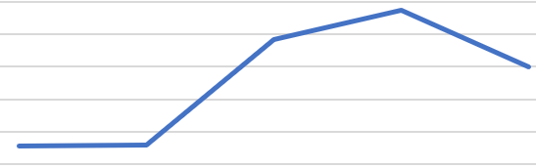
Non-disabled | 42.7% | 49.7% | 49.1% | 43.7% | 48.3% | 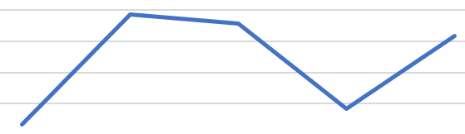

- A decline for disabled staff in 2022 however, in parallel with non-disabled staff. Our ‘No Excuse for Abuse’ campaign will support the improvements, as highlighted in WRES indicator 5, this is also supported by our executive team.
- The Trust’s FTSUG team has also been strengthened and a new FTSUG policy is under development.

WDES Indicator 5 - Percentage of Disabled staff compared to non-disabled staff believing that the Trust provides equal opportunities for career progression or promotion.
 | 2018 | 2019 | 2020 | 2021 | 2022 | Trend
Disabled | 46.2% | 48.9% | 49.8% | 49.7% | 48.7% | 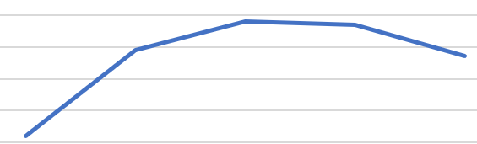
Non-disabled | 51.9% | 55.6% | 55.8% | 57.1% | 57.1% | 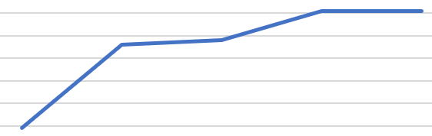

- A decline for disabled staff in 2022, the introduction of 8 coaches within the Trust will support equal opportunities for career progression or promotion.

WDES indicator 6 - Percentage of Disabled staff compared to non-disabled staff saying that they have felt pressure from their manager to come to work, despite not feeling well enough to perform their duties.
 | 2018 | 2019 | 2020 | 2021 | 2022 | Trend
Disabled | 37.1% | 34.6% | 29.4% | 34.6% | 30.3% | 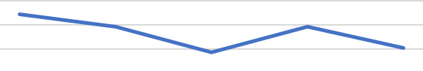
Non-disabled | 22.3% | 19.1% | 20.2% | 24.7% | 24.8% | 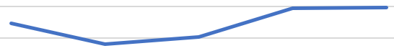

- Positive improvement for disabled staff in 2022, the launch of the Trust Health and Wellbeing passport, clinical psychology support and our mental health first aiders (MHFA).

WDES Indicator 7 - Percentage of Disabled staff compared to non-disabled staff saying that they are satisfied with the extent to which their organisation values their work.
 | 2018 | 2019 | 2020 | 2021 | 2022 | Trend
Disabled | 21.0% | 28.1% | 28.4% | 24.7% | 25.3% | 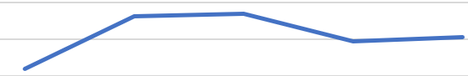
Non-disabled | 36.3% | 41.1% | 46.5% | 35.5% | 37.9% | 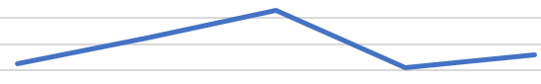

- In 2022, there was a positive improvement for disabled employees, demonstrating how their work is valued. However, this remains below the 2020 levels and much less than for non-disabled staff.

WDES Indicator 8 - Percentage of Disabled staff saying that their employer has made reasonable adjustment(s) to enable them to carry out their work.
 | 2018 | 2019 | 2020 | 2021 | 2022 | Trend
Disabled | 70.2% | 73.8% | 75.4% | 66.7% | 70.6% | 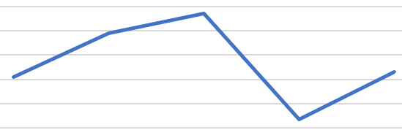

- A positive improvement for disabled employees in 2022, demonstrating that their employer has made reasonable adjustments to enable them to perform their duties.

WDES Indicator 9 - The staff engagement score for Disabled staff, compared to non-disabled staff.
 | 2018 | 2019 | 2020 | 2021 | 2022 | Trend
Disabled | 6.1 | 6.2 | 6.6 | 6.2 | 6.1 | 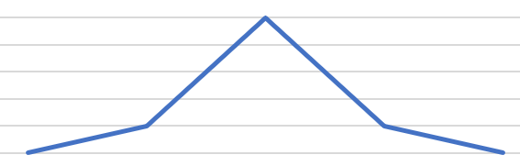
Non-disabled | 6.6 | 6.9 | 6.9 | 6.7 | 6.6 | 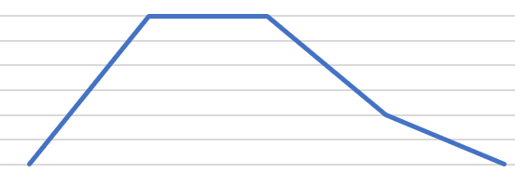

- A slight decline for disabled staff in 2022, remains the same as data taken from 2018.

WDES Indicator 10 - Percentage difference between the organisation’s board voting membership and its organisation’s overall workforce, disaggregated:
- by voting and non-voting membership of the board
- by executive and non-exec membership of the board.

 | 2023
Non-Executive Director and Chair | Disabled | 0
 | Non-disabled | 5
 | Not declared | 3
Board members | Disabled | 0
 | Non-disabled | 7 (4 non-voting)
 | Not declared | 2 (2 voting)

- The data for indicator 10 shows the Trust has no disabled representation at board level. All board members will be encouraged to update their personal information regarding their disability status as this is something we are encouraging all staff to do.

Action Plan
The WDES action plan for 2023/24 (appendix 10) highlights the objective, supporting data, actions currently in place and future actions. It also provides a RAG rating for the actions relating to each metric.
The WDES data has not seen significant improvement, indeed some metrics have declined since data began to be recorded. While data quality has improved the experience of staff has not. Some of the key actions in 2023/24 from the action plan are:
- Reviewing policies, particularly relating to recruitment, capability processes and the raising of concerns to ensure they are inclusive
- HRBPs engaging with managers to support them in providing reasonable adjustments for staff
- FTSUG team providing another outlet for concerns and queries.
- Raising awareness of the positive contribution of staff with disabilities through the staff network.

Conclusion
The Trust has seen some improvements, particularly with the WRES metrics from 2021 to 2022. However, it is clear that the experience of staff from diverse ethnic backgrounds or those with disabilities is worse than their white and non-disabled colleagues.
The 2022/23 data and 2023/24 action plan highlight the continued need to change our processes, approach and culture to ensure that all staff who work at the QEH are treated in accordance with our values of wellness, fairness and kindness.

